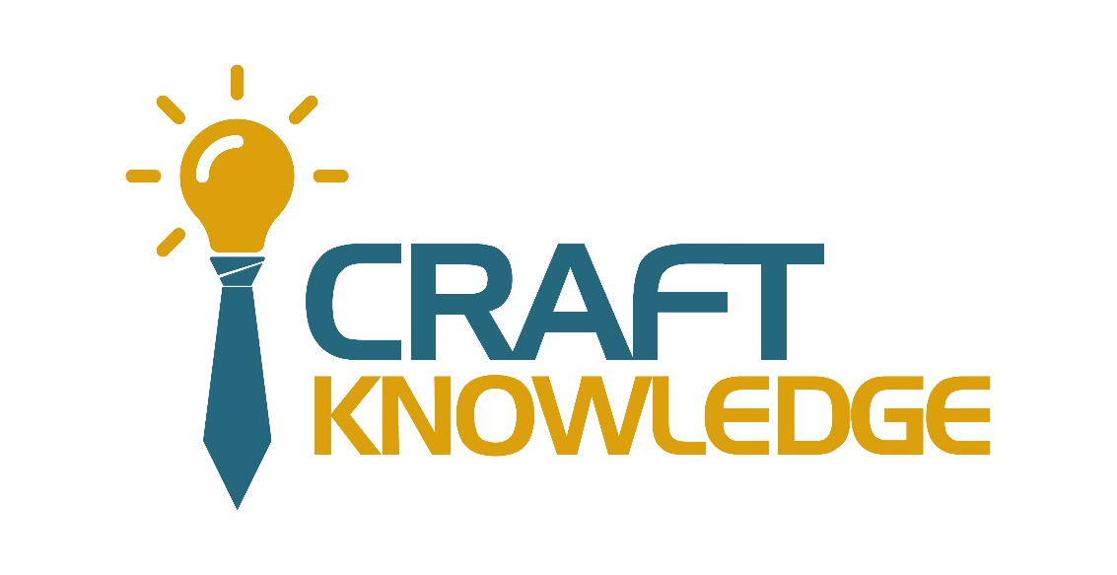

Database

Lab Guide

Short Answer

- what is Data?
- Data is a collection of discrete units of information in a conceptual model that in their most basic forms convey quantity, quality, fact, statistics, or other basic units of meaning.

2. what is Information?
- Information is a fact provided or learned about something or someone.

- what is Database(DB)?

- A database is an organized collection of structured information, or data, typically stored electronically in a computer system

- What is the Relation Database Management System(RDBMS)?
- A relational database management system (RDBMS) is a set of programs that enables the interaction with relational database data using the SQL language.

- Define the importance of Relation Database Management System(RDBMS)?
- An RDBMS, or relational database management system, is a database that stores data items and sets based on how they relate to other items in the system. These database management systems use tables to show the relationships between different pieces of data, which can help make organizing large sets of data with multiple items simple.

- As we all know that there are Two types of Database. Relational Database(SQL) AND Non-Relational DB(NO sql). what is the difference between them.
- There are two main types of databases used in web development: relational and non-relational. The main difference between the two is a type of used structure.

- List examples of Relation Database Management System(RDBMS)?

- Some examples of specific systems that use RDBMS include IBM, Oracle, MySQL, Microsoft SQLServer and PostgreSQL. RDBMS product history. Many vying relational database management systems arose as news spread in the early 1970s of the relational data models.
8. List examples of Non-Relational DB(Nosql)?
- A NoSQL (originally referring to "non-SQL" or "non-relational") database provides a mechanism for storage and retrieval of data that is modeled in means other than the tabular relations used in relational databases.

9. Define and Describe is Structured Query Language(SQL)?
- Structured Query Language (SQL) is a programming language that is typically used in relational database or data stream management systems.

10. List and Describe each of the different subsets of SQL(Mean DDL, DML, DCL, TCL)?
- SQL is a domain-specific language used in programming and designed for managing data held in a relational database management system, or for stream processing in a relational data stream management system.

11. what is table in Database(DB)?
- Tables are database objects that contain all the data in a database. In tables, data is logically organized in a row-and-column format similar to a spreadsheet. Each row represents a unique record, and each column represents a field in the record.

12. what is column and Row(tuples) in table?
- A row is a series of data banks put out horizontally in a table or spreadsheet. A column is a vertical series of cells in a chart, table, or spreadsheet.

To Be Continued…

